Cypherworx Registration Instructions – UBMD EMS

Everyone will be required to register and create an account with Cypherworx before you are able to begin any training modules.

- Start by navigating to the following webpage: https://collabornation.net/register/UBMD

- You should be directed to the page shown below. Please complete the information as a first time user of the system. Once complete, press the ‘Create Account’ button at the bottom of the page.

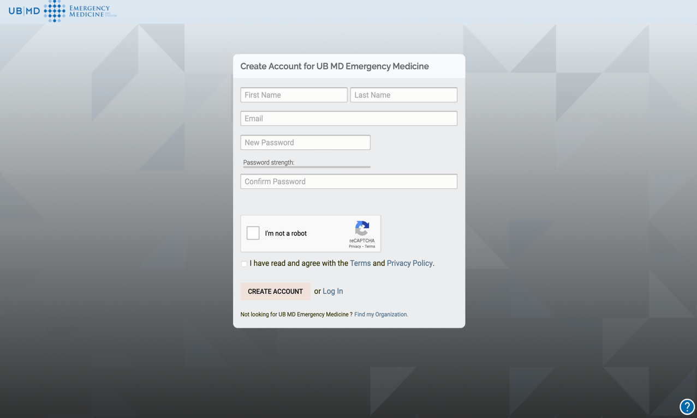

- If all your information was entered correctly, you should be directed to the following page. Please select the blue ‘Join Free’ button to continue the enrollment process.

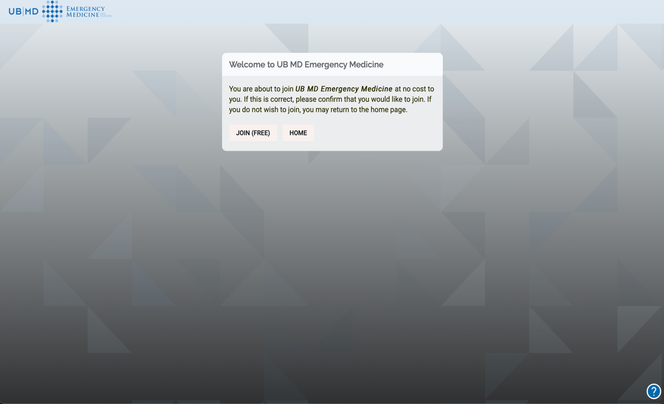

- Select ‘Yes’ to confirm your enrollment.

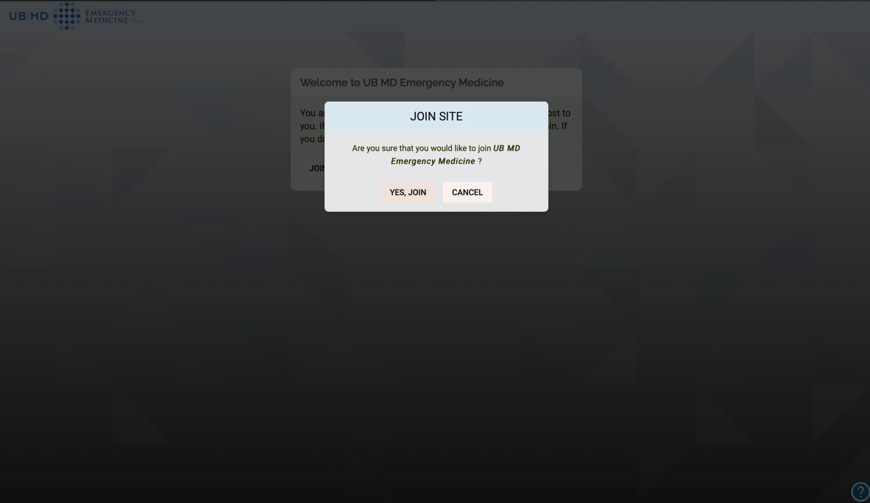

- Fill out the required fields for registration.

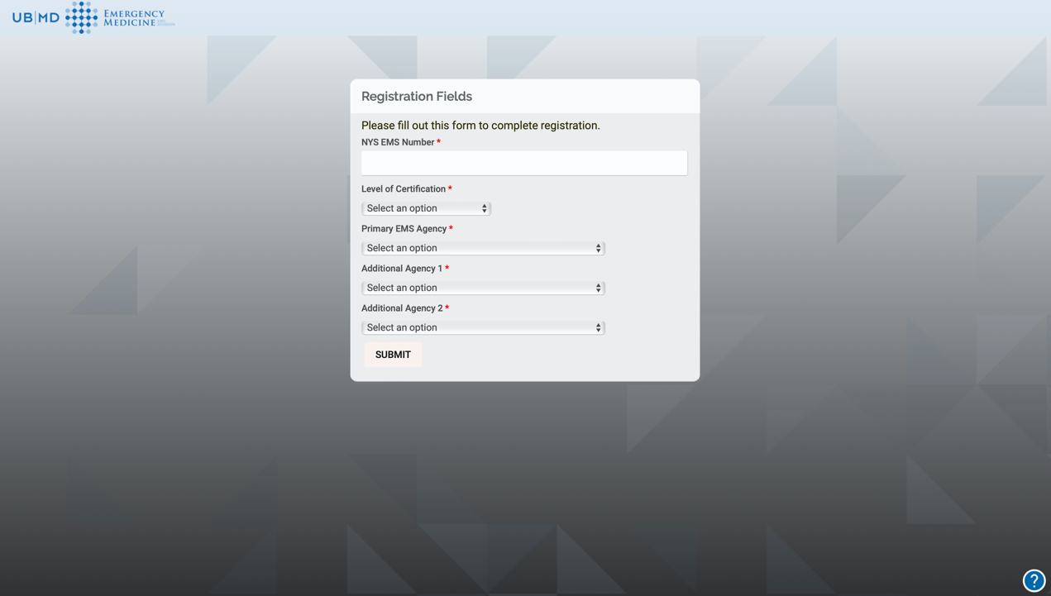

- Upon completion, it will bring you to the landing page. Please remember to book mark the site.

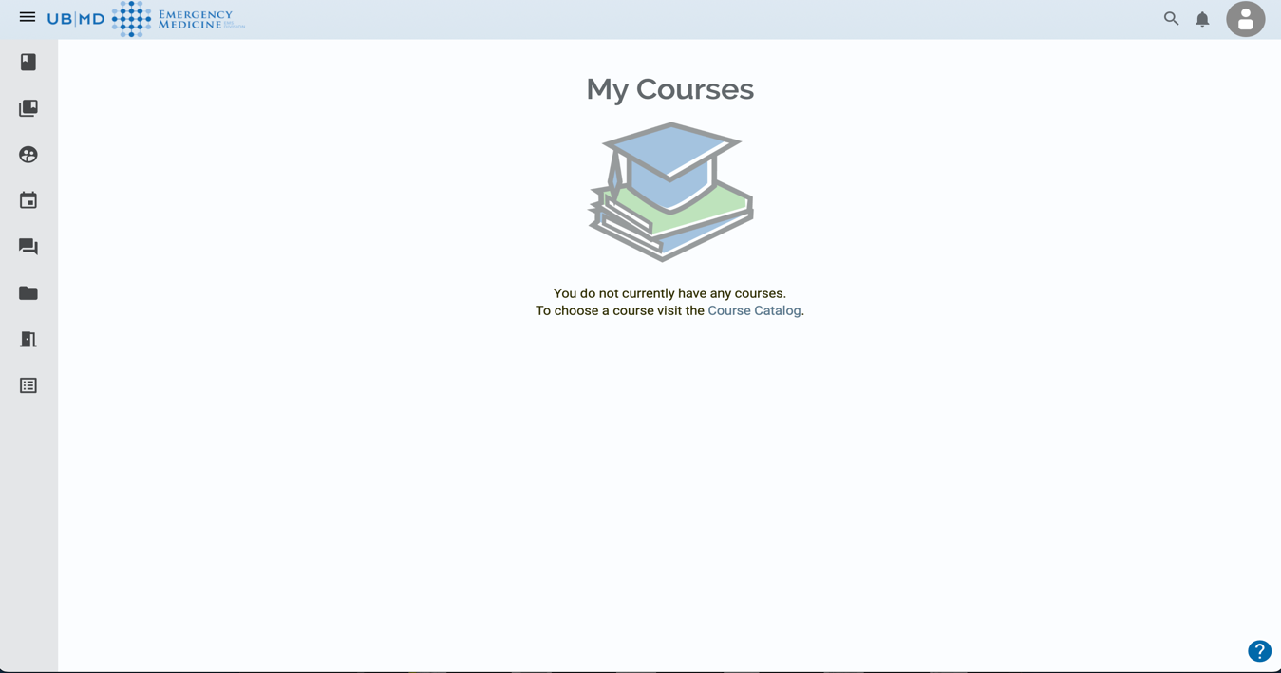

If you have any questions, or require any assistance, please reach out to either Mike Shaw – mshaw5@buffalo.edu for the Blg Lakes Region, or Robert McCartin – rmccarti@buffalo.edu, in the Wyoming/Erie Region

